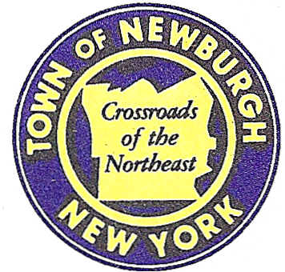

TOWN OF NEWBURGH
_______Crossroads of the Northeast __________________________
OLD TOWN HALL
308 GARDNERTOWN ROAD NEWBURGH, NEW YORK 12550

PLANNING BOARD
JOHN P. EWASUTYN, CHAIRMAN
TELEPHONE 845-564-7804
FAX 845-564-7802
E-MAIL: planningboard@townofnewburgh.org

PLANNING BOARD AGENDA

May 19th, 2016

*PLEASE NOTE: The Planning Board Meeting will start at 7:00 P.M. and all Applicants/Representatives
are to be present at that time. The Meeting will be held in the Meeting Room of Town Hall,
located at 1496 Route 300, Newburgh NY.*

1. Barton Chevy (2015-15) AMENDED SITE PLAN
800 Auto Park Drive
Section 97, Block 2, Lot 27.32
Zone: IB
Rep: Mercurio, Norton Tarolli, Marshall
45 Main Street
Pine Bush, N.Y. 12566

2. Gardnertown Commons (2016-03) AMENDED SITE PLAN
Section 75, Block 1, Lot 21
Zone: R-3
Rep: JMC Planning Engineering and
Landscaping
120 Bedford Road
Armonk, N.Y. 10504

3. Meadow Hill Expansion LLC (2016-07) INITIAL APPEARANCE SITE PLAN
Section 60-1-9.1 & 9.2
Zone: R-3
Rep: Jacoowitz & Gubits
John Cappello
158 Orange Avenue
Walden, N.Y. 12586

4. Barron/Monaco (2016-08) INITIAL APPEARANCE
416 Rock Cut Road-26 Copper Rock Road LOT LINE CHANGE
Section 28 Block 1 Lot 25
Section 125 Block 1 Lot 13
Zone: R-1
Rep: Engineering Properties
Ross Winglovitz
71 Clinton Street
Montgomery N.Y. 12549

PLANNING BOARD BUSINESS
WORK SESSION

May 19, 2016

1. Longview Farm/Summer Kim (2006-39) 6 month extension. Tom Depew

